Fr. Clement Nicholas Gustin, osc, dies in Onamia
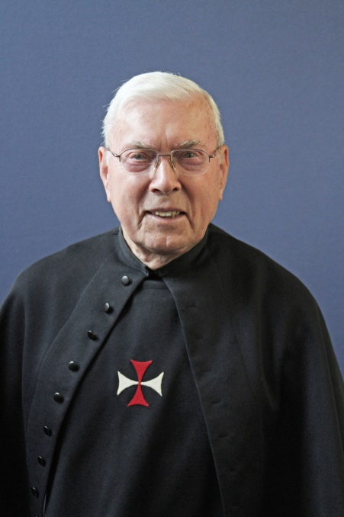
The Crosier Fathers and Brothers mourn the loss of our brother, Fr. Clement “Clem” Nicholas Gustin, osc, who was born Oct. 2, 1925, to Michael and Rose (Schmidt) Gustin in Flasher, North Dakota.
He died in Onamia, Minnesota, Nov. 2, 2019, at Mille Lacs Health System Long-Term Care. He was 94 years old.
Fr. Clem attended Flasher public schools in Flasher, North Dakota, during his elementary and high school years, Crosier Seminary Junior College in Onamia, and the Crosier House of Studies in Fort Wayne, Indiana, where he earned a degree in philosophy in 1952. He continued his education at Immaculate Conception Monastery in Hastings, Nebraska, the University of Notre Dame and St. Francis College in Fort Wayne. He completed his graduate studies at the University of Michigan in 1964 with a Master of Arts degree in Classical Studies.
He joined the Crosiers as a novice in 1949 and made his first profession of vows Aug. 28, 1950, in Hastings, Nebraska. He was ordained a priest May 28, 1955, in Hastings.
After his ordination, Fr. Clem was assigned to the Crosier House of Studies in Fort Wayne as secretary to the vicar general. He then served as associate editor and business manager for the Crosier magazine “Today’s Family” in Onamia, Minnesota. He was a Latin teacher at Crosier Seminary in Onamia and at Our Lady of the Lake Seminary in Syracuse, Indiana for a total of 10 years. Fr. Clem also worked in different capacities for the Province of St. Odilia including as vice provincial and as novice director. He later served in parish ministry as assistant pastor, pastor and senior associate in various parishes in Minnesota and Nebraska. In 2008, Fr. Clem retired to the Crosier community in Onamia where he shared in Crosier Religious Life and joyfully served as liturgical organist, accompanying Crosier prayer for many years.
Fr. Clem’s funeral Mass will be celebrated at the Crosier Priory church in Onamia on Saturday, Nov. 9, 2019, at 1:00 p.m. with a vigil beginning at noon. The burial take place in the priory cemetery following the liturgy. A luncheon will be served at the priory after the service.
Fr. Clem is survived by his Crosier confreres, a large extended family, and 5 of his 14 siblings: Veronica Goeppinger, Alice (Al) Ternes, Isabelle Mahrer, Joan Eckroth and Hugo (Martha). He was preceded in death by his parents and his siblings Fred, John, Paul (Leona), Andrew (Shirley), Cecilia Hoffman, Angela Kopp, Phyllis Restivo, Carol Miller and Irene Riehl.
Memorials are preferred to the Crosier Fathers and Brothers, P.O. Box 500, Onamia, MN 56359-0500.

